**ASSIGNMENT 2 FRONT SHEET**

|  |  |  |  |
| --- | --- | --- | --- |
| **Qualification** | **BTEC Level 5 HND Diploma in Computing** | | |
| **Unit number and title** | Unit 43: Internet of Things | | |
| **Submission date** |  | **Date Received 1st submission** |  |
| **Re-submission Date** |  | **Date Received 2nd submission** |  |
| **Student Name** | Nguyen Duc Cong | **Student ID** | GCD191033 |
| **Class** |  | **Assessor name** | Tran Trong Minh |
| **Student declaration**  I certify that the assignment submission is entirely my own work and I fully understand the consequences of plagiarism. I understand that making a false declaration is a form of malpractice. | | | |
|  |  | **Student’s signature** |  |

**Grading grid**

|  |  |  |  |  |  |  |
| --- | --- | --- | --- | --- | --- | --- |
| P5 | P6 | P7 | M5 | M6 | D2 | D3 |
|  |  |  |  |  |  |  |

|  |  |  |
| --- | --- | --- |
| **❒ Summative Feedback: ❒ Resubmission Feedback:** | | |
| **Grade:** | **Assessor Signature:** | **Date:** |
| **Internal Verifier’s Comments:** | | |
| **Signature & Date:** | | |

# Practical IoT application.

## Problem.

Vietnam is a country that annually suffers a lot of natural disasters. Especially in the central coastal plain. Every year in the rainy season, this area often floods. In 2020, Due to heavy rains, two floods appeared in succession on rivers from Ha Tinh to north of Binh Dinh and Kon Tum. Of which, in some places, flood peaks have exceeded historical levels such as the Hieu River (Quang Tri) in Dong Ha which is 4.69 m (October 8), the historic flood peak in 1983 was 0.11 m. However, right after that, on October 18, the flood peak on the Hieu river in Dong Ha was 5.36 m, surpassing the newly established historical water level; the flood peak on the Bo River in Phu Oc (Thua Thien Hue) was 5.24 m, the historic flood peak in 1999 was 0.06 m; The flood peak on Thach Han River in Thach Han was 7.4 m, and it exceeded the historic flood peak in 1999 of 0.11 m. (Anon., n.d.)

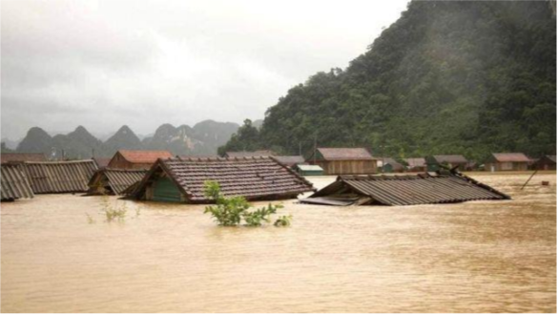

Drought is another natural disaster that needs attention. Take the one happen in 2016 at Cuu Long River Delta. During this drought, there were 13 provinces in the Mekong Delta that were salty intruded. 10 provinces have announced natural disasters, in which many provinces have declared level 2. In many estuaries, the salinity has increased to more than 30g / l. 20 million people in the Mekong Delta have been affected. According to estimates by the Ministry of Agriculture and Rural Development of Vietnam, about 160,000 hectares of rice were damaged, an estimated 800,000 tons of rice were lost. Provinces that suffered the most in this drought were Kien Giang (more than 54,000 ha), Ca Mau (nearly 50,000 ha), Ben Tre near (14,000 ha), Bac Lieu near (12,000 ha). (Anon., n.d.)

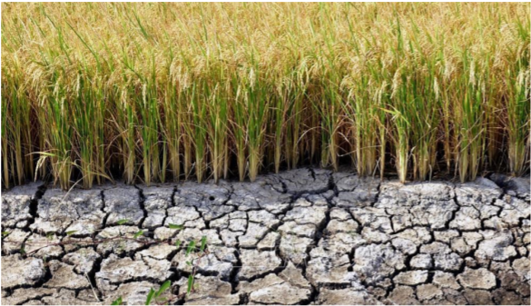

These natural disasters cost the country trillions of VND each year and affect the lives of people, especially farmers.

## Solution.

From the problem above, I come up with the solution that is WaMe, an IoT solution.

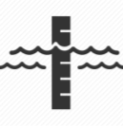

The system will display water levels in water sources such as rivers and lakes, when the water level exceeds the allowable threshold or is lower than the allowable threshold, the system will display onscreen warning about the risk of flood or drought.

As a result, people can know and prepare methods to cope with natural disasters, limit the loss of life and property.

## Overview

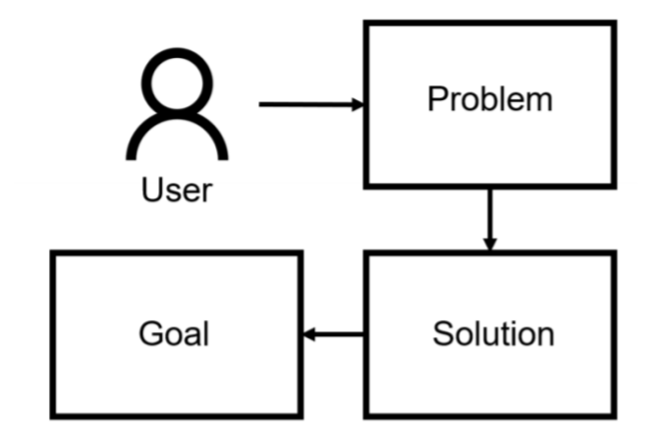

# Product design.

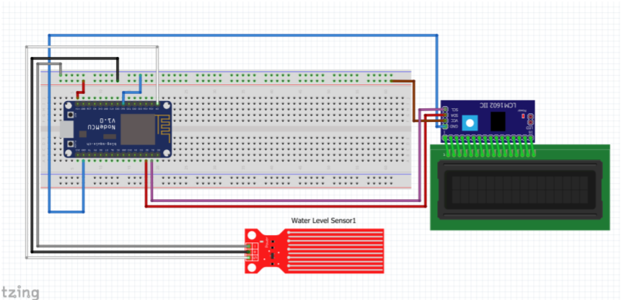

Currently, this project is being developed by me and is running smoothly. The equipment used in the project is a water level sensor used to measure the water level in rivers and lakes. Data is sent to ESP8266. The ESP8266 is programmed to display the received data on the LCD screen via the I2C module. ESP8266 is also programmed to send data to Blynk server and the data will be displayed in the Blynk application on the phone so that users can check every day.

**SDLC**

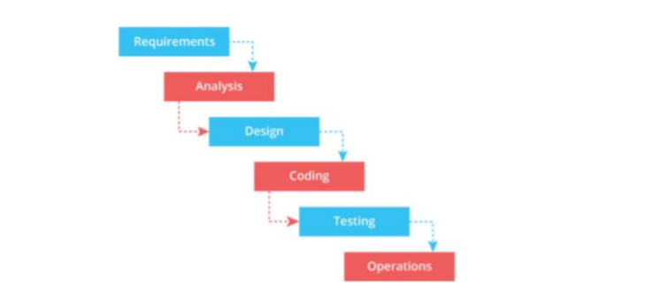

I choose Waterfall model for this project because it’s so simple and invested with small scale. The project base on original requirements so it is easy to understand.

# Product planning

## GANTT chart

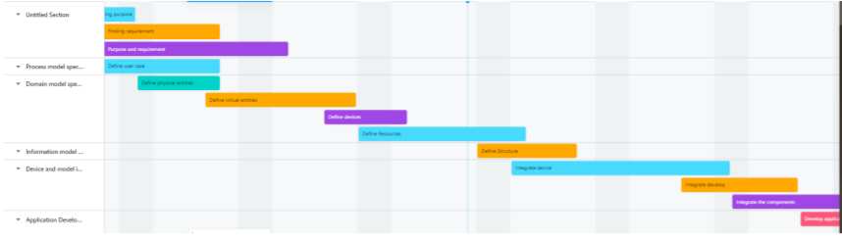

## Components

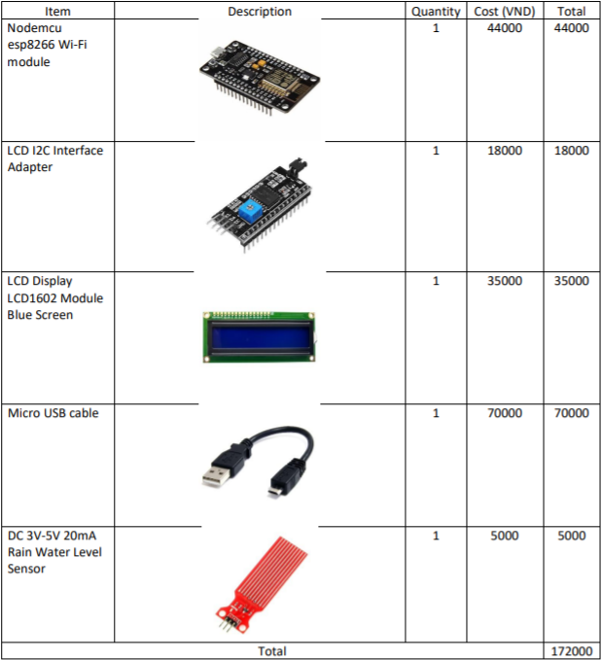

# IDE

## Arduino IDE.

Arduino IDE is free for both download and copyright: Users have the right to modify, improve, develop, and upgrade according to some general principles allowed by the publisher without permission, which they are not authorized to do closed source software.

Although it is open source software, but the information security capability of Arduino IDE is extremely great, when it detects a bug, the publisher will patch it and update very quickly so that the user's information is not lost or leaked. outside.

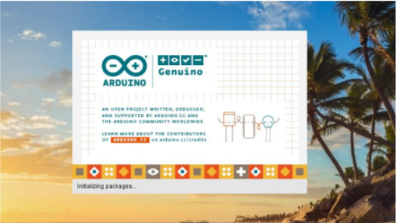

The source code for the IDE is released under the GNU General Public License, version 2. The Arduino IDE supports the languages C and C++ using special rules of code structuring. The Arduino IDE supplies a software library from the Wiring project, which provides many common input and output procedures. User-written code only requires two basic functions, for starting the sketch and the main program loop, that are compiled and linked with a program stub main() into an executable cyclic executive program with the GNU toolchain, also included with the IDE distribution. The Arduino IDE employs the program avrdude to convert the executable code into a text file in hexadecimal encoding that is loaded into the Arduino board by a loader program in the board's firmware. By default, avrdude is used as the uploading tool to flash the user code onto official Arduino boards.

The Arduino has a board management module where users can choose which boards they want to work with and can change boards via the Menu. The selection modification process is also continuously updated automatically so that the existing onboard data and the revised data are identical. In addition, the Arduino IDE also helps you find errors from the code you know to help you correct errors in time to avoid the Arduino board working with the error code for too long leading to damage or reduced processing speed. (ASM1)

## Blynk

Blynk was designed for the Internet of Things. It can control hardware remotely, it can display sensor data, it can store data, visualize it and do many other cool things.

There are three major components in the platform:

* Blynk App - allows to you create amazing interfaces for your projects using various widgets we provide.
* Blynk Server - responsible for all the communications between the smartphone and hardware. You can use our Blynk Cloud or run your private Blynk server locally. It’s open-source, could easily handle thousands of devices and can even be launched on a Raspberry Pi.
* Blynk Libraries - for all the popular hardware platforms - enable communication with the server and process all the incoming and out coming commands.

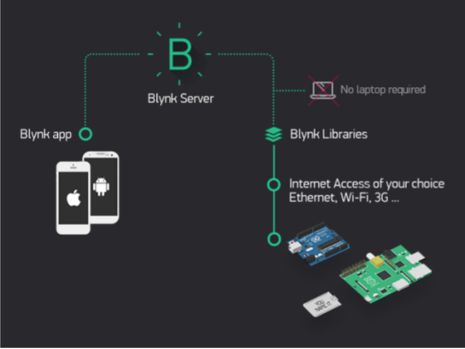

**Features**

* Similar API & UI for all supported hardware & devices
* Connection to the cloud using:
* WiFi
* Bluetooth and BLE
* Ethernet
* USB (Serial)
* GSM
* …
* Set of easy-to-use Widgets
* Direct pin manipulation with no code writing
* Easy to integrate and add new functionality using virtual pins
* History data monitoring via SuperChart widget
* Device-to-Device communication using Bridge Widget
* Sending emails, tweets, push notifications, etc.
* … new features are constantly added!

You can find example sketches covering basic Blynk Features. They are included in the library. All the sketches are designed to be easily combined with each other. (Anon., n.d.)

# Develop product.

## Actual product

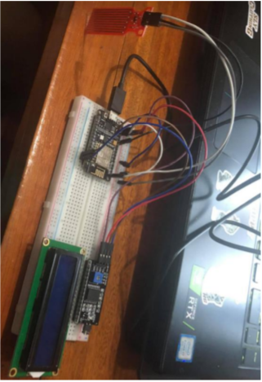

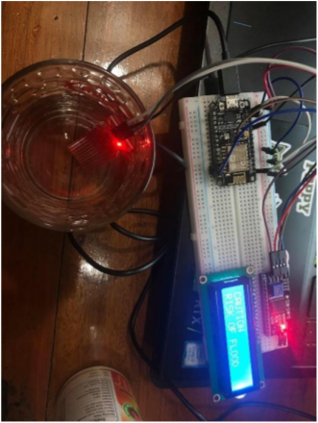

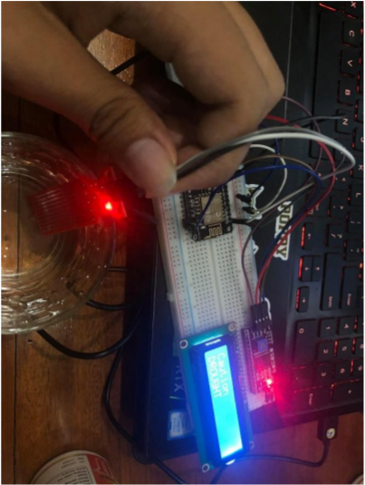

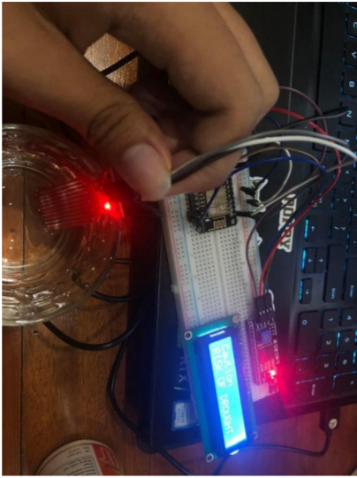

## Code snippet.

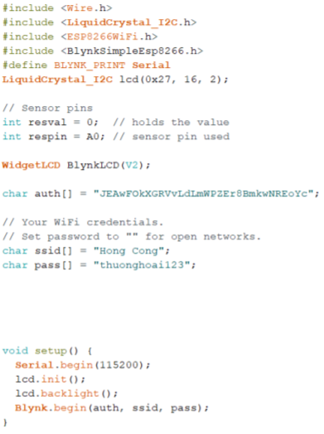

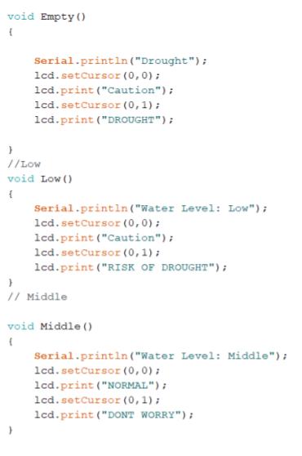

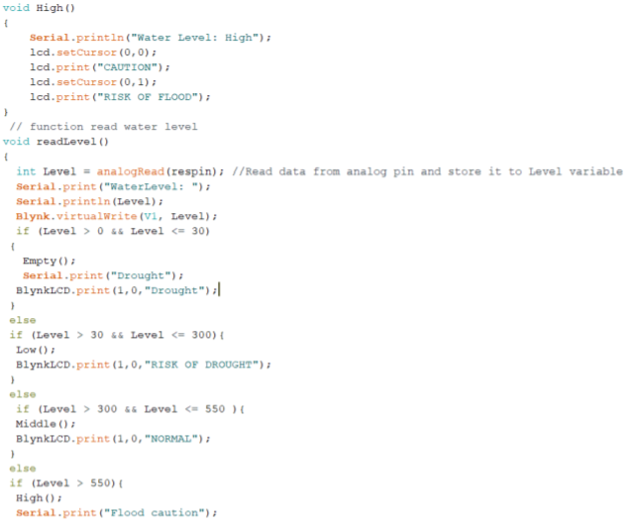

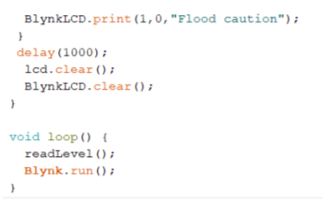

## Blynk application

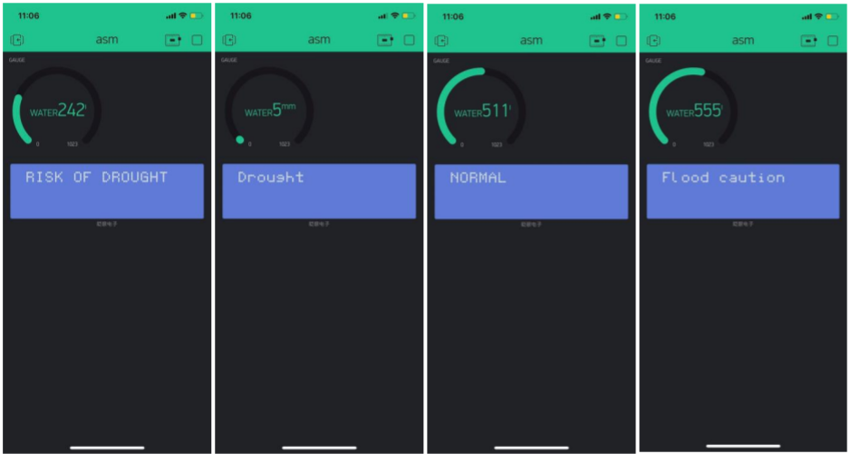

## Test case

|  |  |  |  |  |  |
| --- | --- | --- | --- | --- | --- |
| No. | Action | Input | Expected result | Actual result | Test result |
| 1 | ESP8266 connect to wifi | Load the wifi connection code | Successfully connected to Wifi | Successfully connected to Wifi | PASS |
| 2 | ESP8266 connect Blynk | Load the Blynk connection | Successfully connected to Blynk | Successfully connected to Blynk | PASS |
| 3 | Check sensor operation | Load sensor working code | Display correct data | Display correct data | PASS |
| 4 | Check sensor operation | Load sensor working code | Display correct data | Display correct data | PASS |
| 5 | Check the Waterproof of system | Put the system into the water | The sensor still working | The sensor working well | PASS |

# End-User experiments and examines feedback.

## Practical application.

The problem is not uncommon especially in the past years. Natural disasters combined with climate change and environmental pollution make the consequences more severe. With the development of technology and human creativity, the problem can be solved in order to protect human life as well as economy.

## Evident for apply WaMe in practice.

How does WaMe work well? It requires detailed stakeholder assessments and mixed feedback. From those results, it is possible to make reviews, improve and overcome the bad points of the product. Table 2 is a test case for applying this product in practice.

## Point achieved and not achieved

**Points achieved:**

* The sensor works well under water.
* Helps recognize some extreme weather phenomena effectively.
* Easy to use
* Information transmitted from the sensor correctly.
* Easy installation and construction

**Fail Scopes:**

* May cause damage with extreme weather in a long time.
* May be damaged if the water level exceeds the expected threshold.
* Fixed power supply required
* Can't function properly without wifi.

# Review and evaluation.

## Product quality survey

Through the questionnaire sent to 12 users of the WaMe system experience, 10 users answered the questionnaire and had 12 valid questionnaires. General statistics on purpose achieved after using the following questioning system:

This IoT is a comprehensive system consisting of hardware and software. It is important to identify key stakeholders:

* Customer: Does using the application meet the needs of the customer? Are the users satisfied with the product or have problems using it?
* Developer: Are there any improvements in project execution, have the hardware and Software functionality has been stabilized? Need to improve or change any hardware or software?

After the product was completed, I rushed to market with a demo for 12 users over a period of 1 month. They will receive the device for free until the end of the 1-month period and complete the following survey:

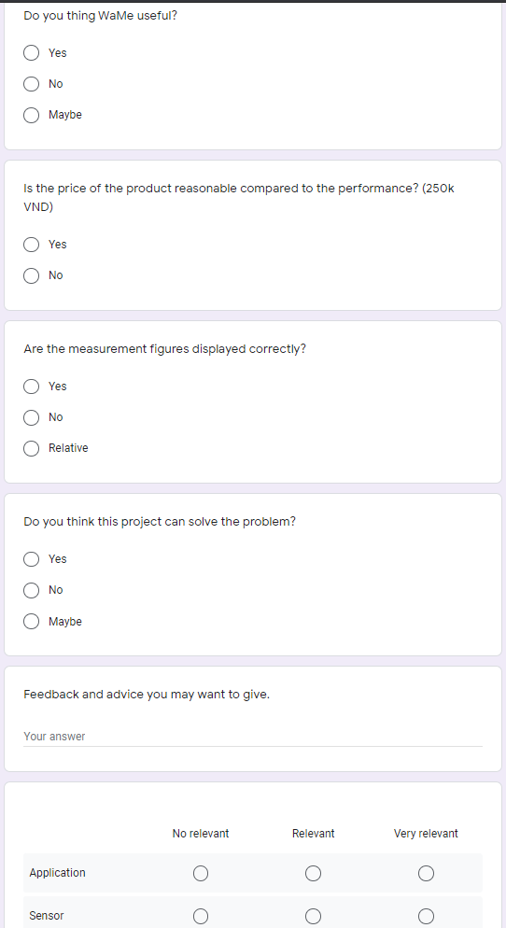

## Does problem solve?

My product has been brought to the market with a free demo for 12 users, the results are quite positive. Most of them responded positively, which also meant that the WaMe device really helped them to solve this problem. According to the survey results:

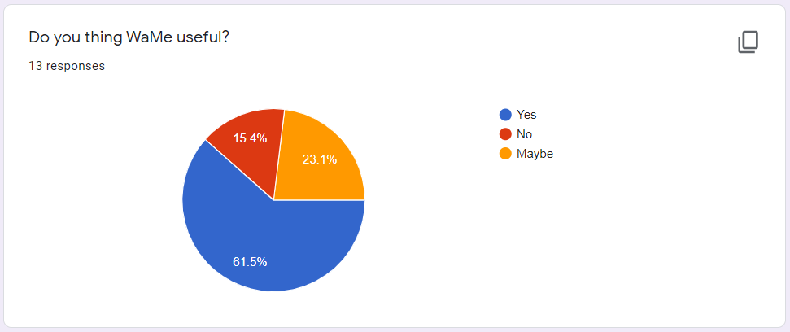

Most of the survey participants have good reviews when experiencing the system.

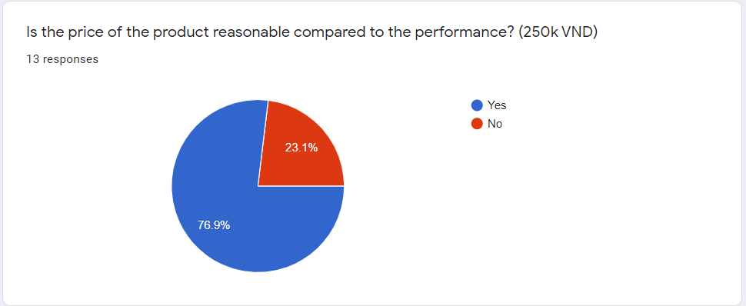

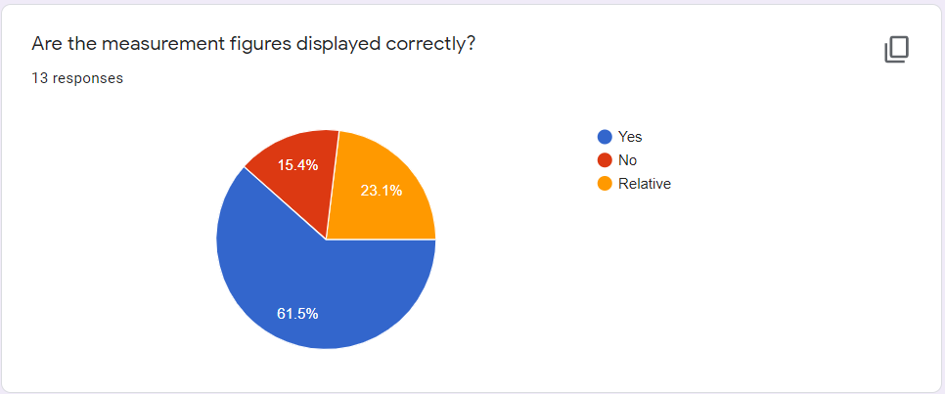

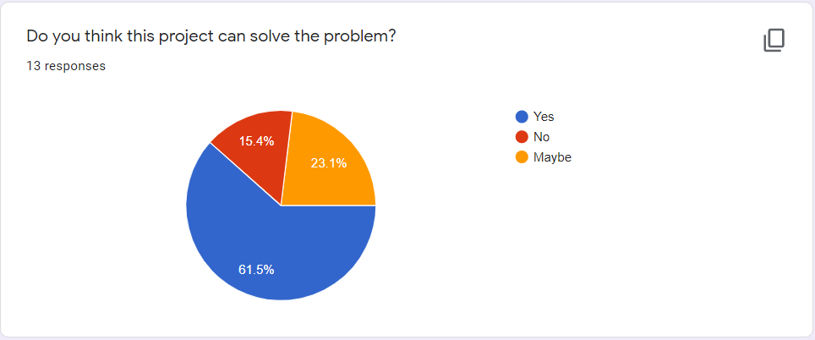

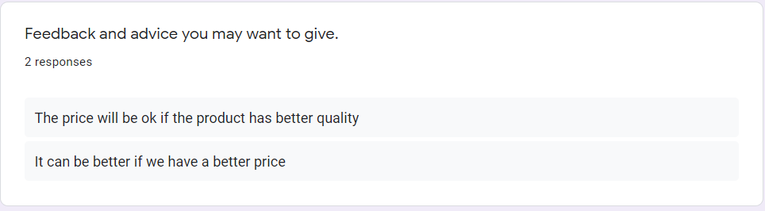

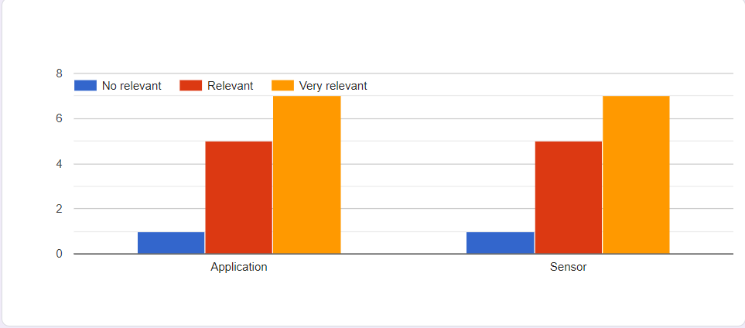

Regarding weather warning, users have felt how the system works to solve the problem, but besides that, there are still unresolved issues.

The good point here, is that the majority of users consider the measured metrics to be accurate. This shows that the sensor works relatively smoothly. But besides that, there are still people who think that the measured indicators are wrong or relevant. shows that in some cases the system will not work correctly. This leads to the fact that even though the system may work efficiently and correctly at first, if it is operated for a long time and the conditions are not ideal, problems may occur.

According to user reviews and opinions, the price of the product is somewhat high compared to the quality of the product. The product is commercially viable but needs to be reduced in price if it wants to reach more customers. Or it is possible to enhance the quality of the product such as improving the user interface or using an ultrasonic sensor instead.

Based on user feedback, the system needs to upgrade sensors and applications, and improve UI to make it easier for users to use.

The product needs a constant and sustainable power source, so it is possible to apply solar power to ensure continuous operation.

* Absolutely water resistant systems are needed to be sure in cases where the water is too high.
* Upgrade the case with weather-resistant materials to ensure the product's durability
* Software and UI to operate the system are used through the Blynk platform, so they have not provided a complete application for users. The next version of WaMe will create an app for Android and IOS phones.
* The system transmits data over wifi, so in some cases due to internet problems, the system will not work properly. In the next version, new hardware to support 3G network will applied.

# References

Anon., n.d. [Online]

Available at: <https://nhandan.com.vn/tin-tuc-xa-hoi/thien-tai-cuc-doan-di-thuong-628407/>

Anon., n.d. [Online]

Available at: <https://nhandan.com.vn/tin-tuc-xa-hoi/thien-tai-cuc-doan-di-thuong-628407/>

Anon., n.d. [Online]

Available at: https://docs.blynk.cc/